Lesson 2 Demo 3: Create a Pod with Resource Requirements and Limits

This section will guide you to:

* Create a pod with certain resource requirements and limits

This lab has one sub-section, namely:

1. Creating a pod with certain resource requirements and limits

**Note:** If you don’t have an existing Kubernetes cluster, refer to the Demo 1.1 of Lesson 1.

**Step 1:** Creating a pod with certain resource requirements and limits

* Use the following command to create a custom namespace

*kubectl create namespace cpu-example*



* Create a custom yaml with our resource limits (CPU, memory) as shown below:

*vi cpu-request-limit.yaml*

* Add the following code into the *cpu-request-limit.yaml* file and save it:

*apiVersion: v1*

*kind: Pod*

*metadata:*

*name: cpu-demo*

*namespace: cpu-example*

*spec:*

*containers:*

*- name: cpu-demo-ctr*

*image: vish/stress*

*resources:*

*limits:*

*cpu: "1"*

*requests:*

*cpu: "0.5"*

*args:*

*- -cpus*

*- "2"*

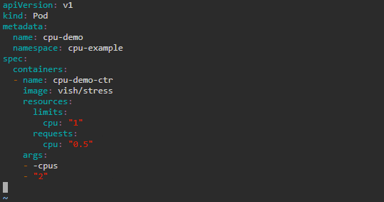

**Note:** Press **Esc** button and enter **:wq** to save and exit the text editor

* Use the following command to create a namespace with the defined limit configuration and limit:

*kubectl apply -f cpu-request-limit.yaml*



* Use the following command to see the detailed information of the *cpu-demo* pod:

*kubectl get pod cpu-demo --namespace=cpu-example*

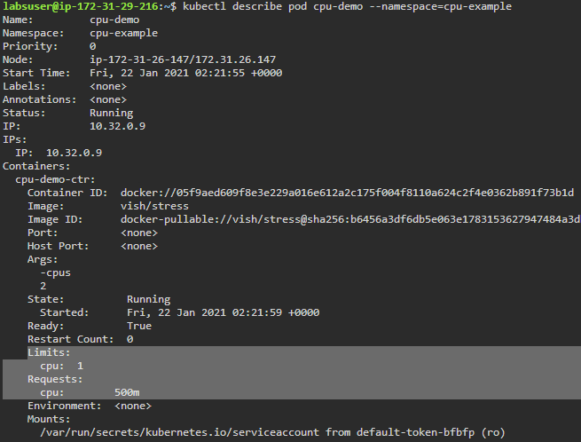

**Note:** The output shows that one of the containers in the pod has a CPU request of 500 milliCPU and a CPU limit of 1 CPU.